## **Part 2- Final Project Report**

* **Staging to Integration (Talend ETL Job):**

1. **Date Dimension -**

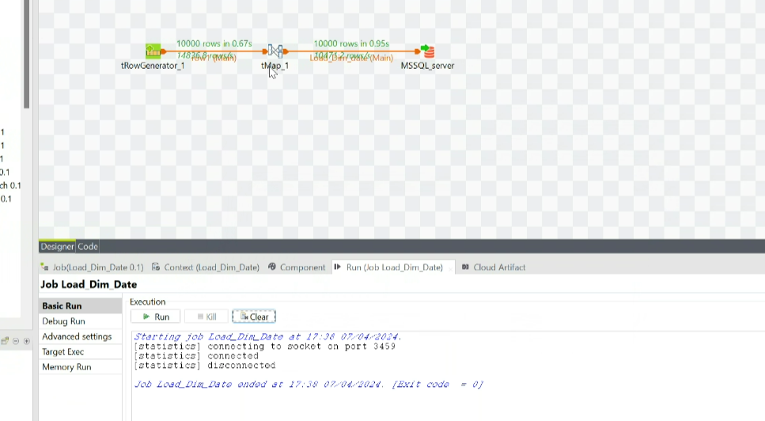

**Count**:-

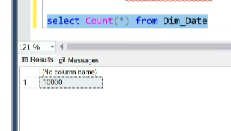

1. **Source Dimension –**

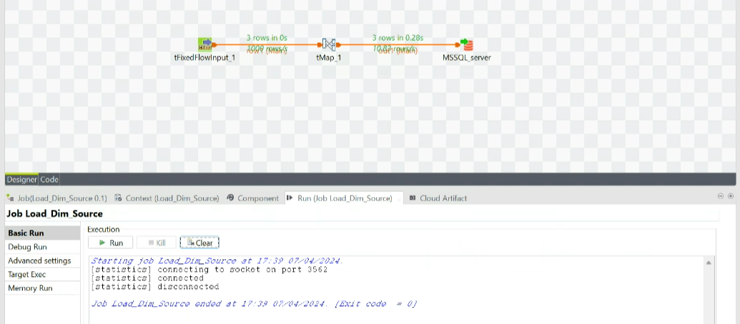

**Count**:-

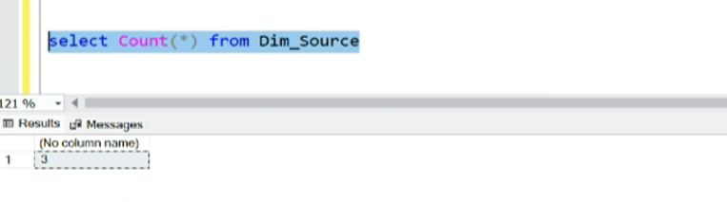

1. **Time Dimension –**

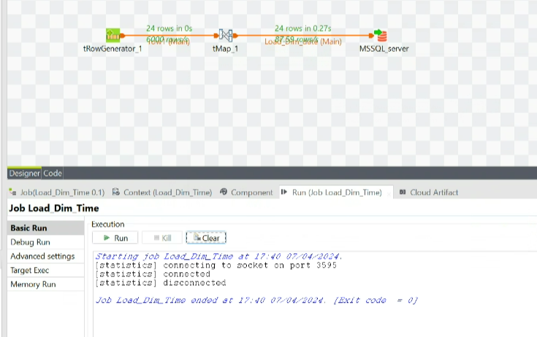

**Count**:-

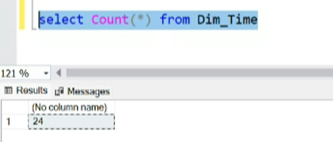

1. **Location Dimension –**

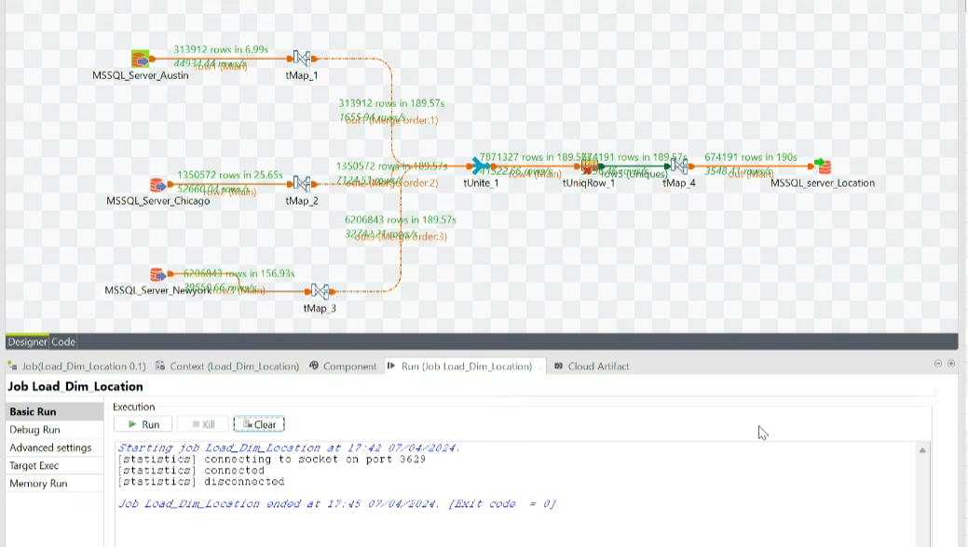

**Count**:-

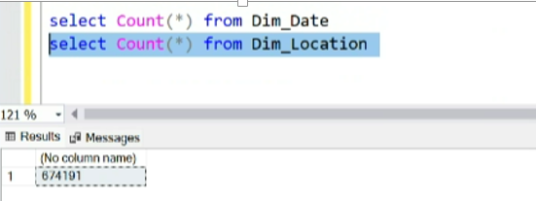

* **Dimension Table Loading :-**

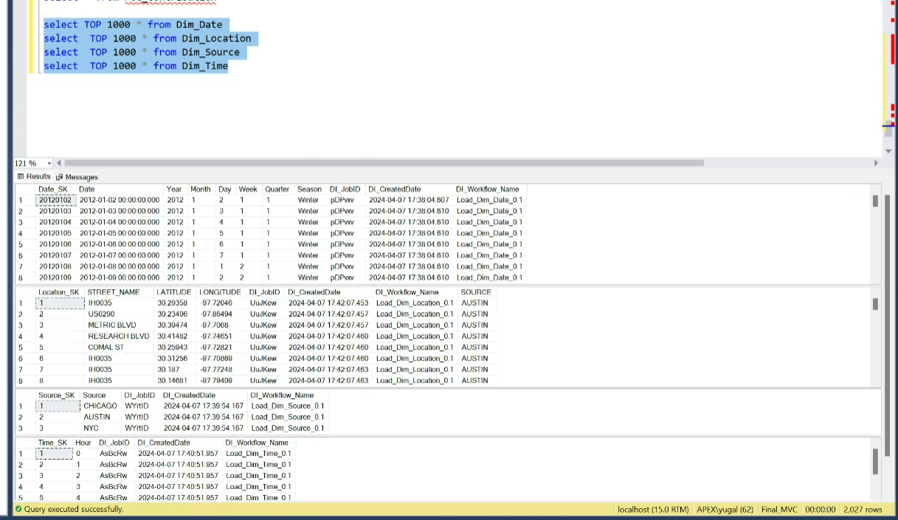

1. **Accident Fact (Chicago) –**

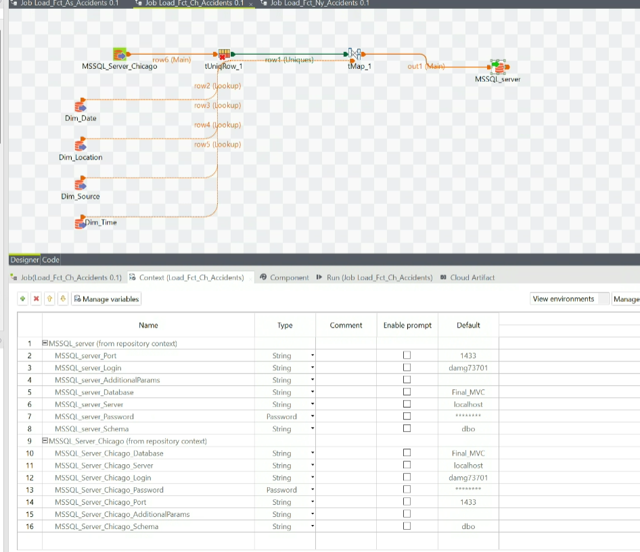

1. **Accident Fact (New York) –**

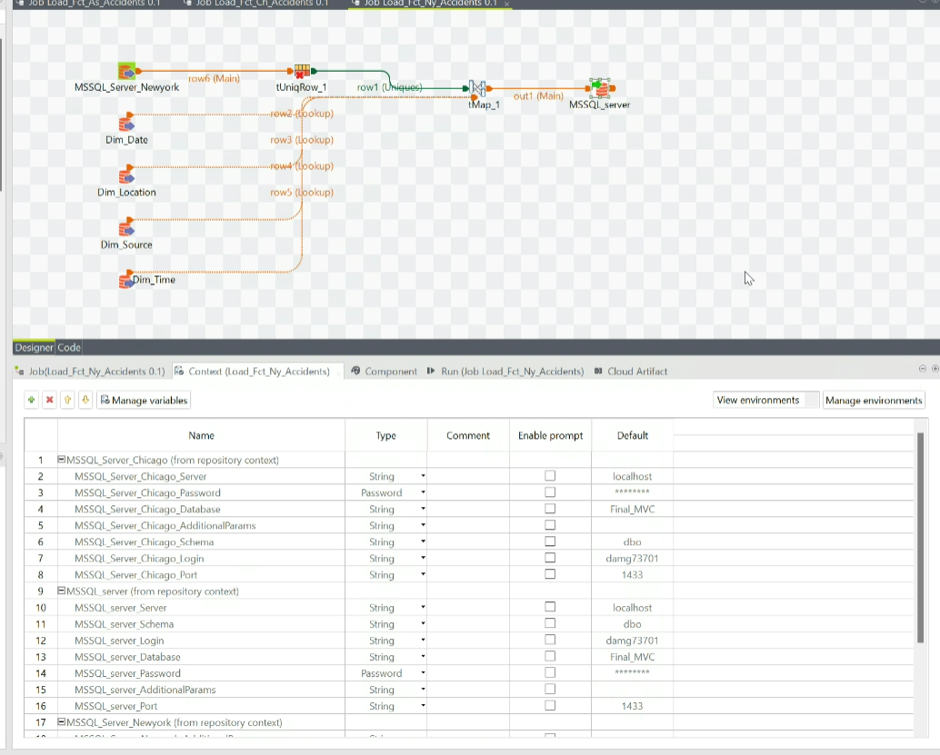

1. **Accident Fact (Austin)–**

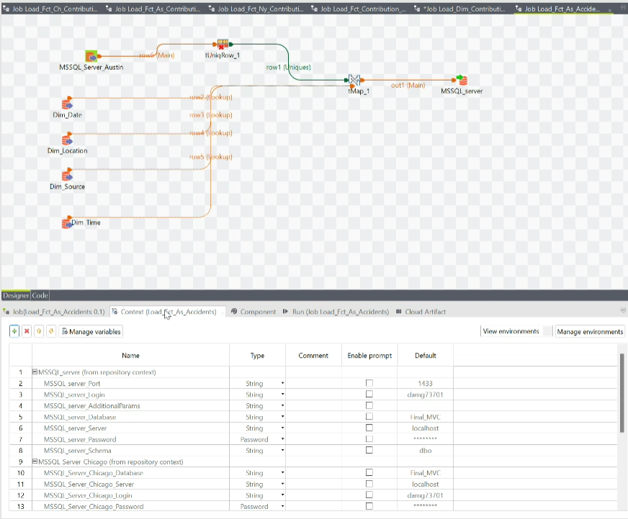

1. **Orchestration Job (Accident Fact) –**

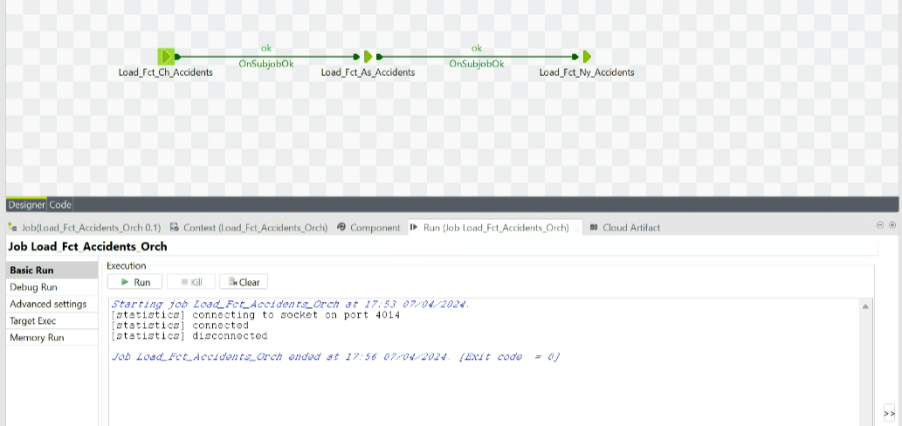

* **Fact Table Loading (Accident Fact) :-**

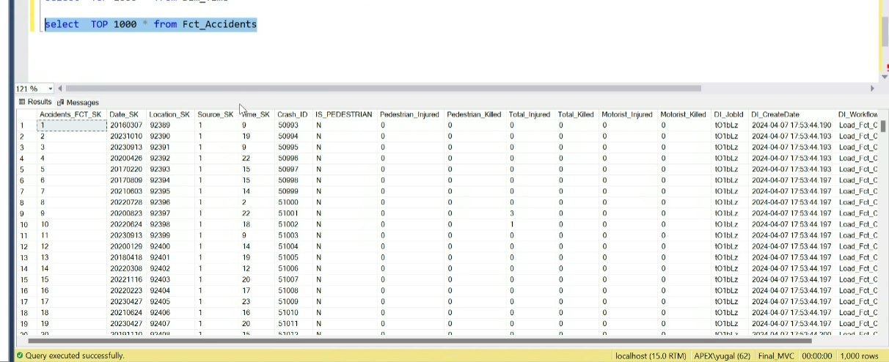

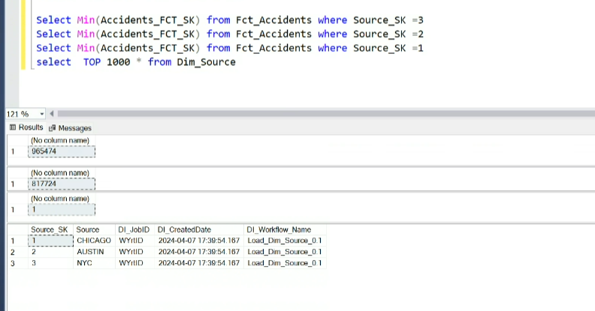

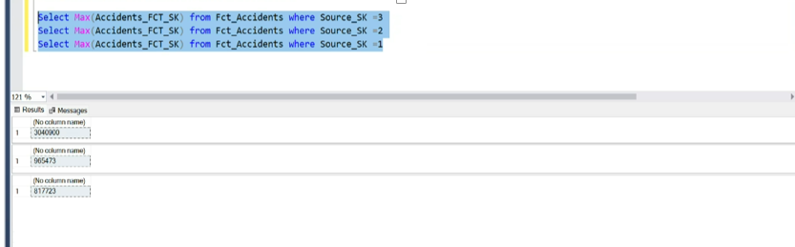

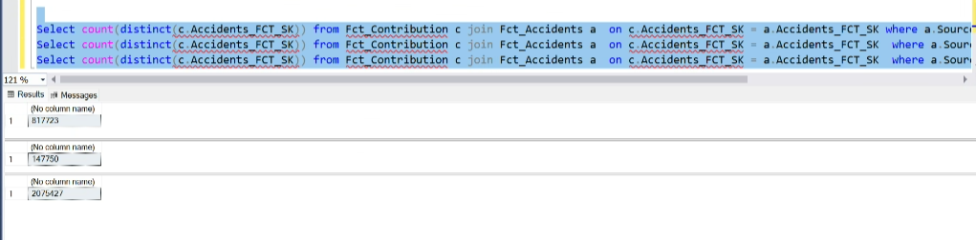

**Table Schema:**

SELECT *

FROM INFORMATION_SCHEMA.COLUMNS

WHERE TABLE_NAME = N'Fct_Accidents

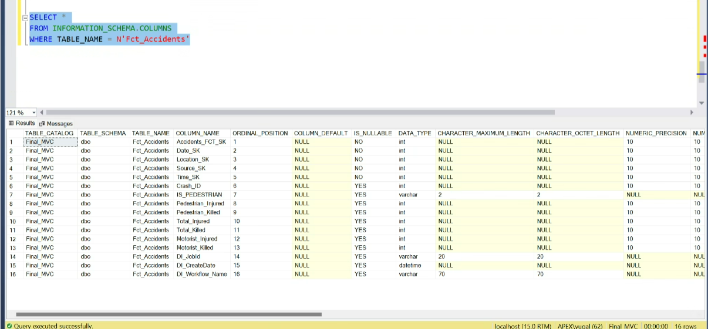

1. **Vehicle Dimension -**

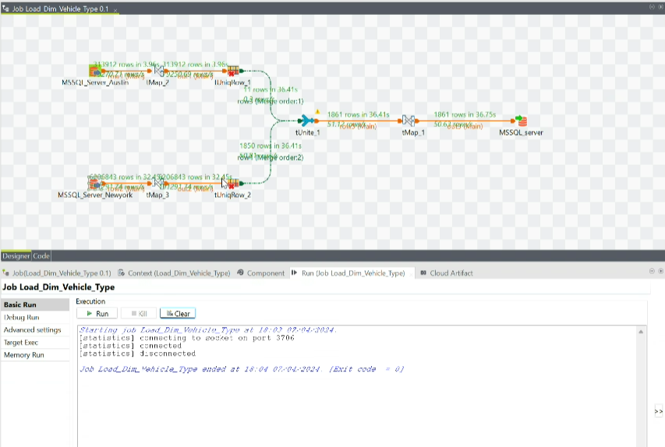

* **Dimension Table Loading :-**

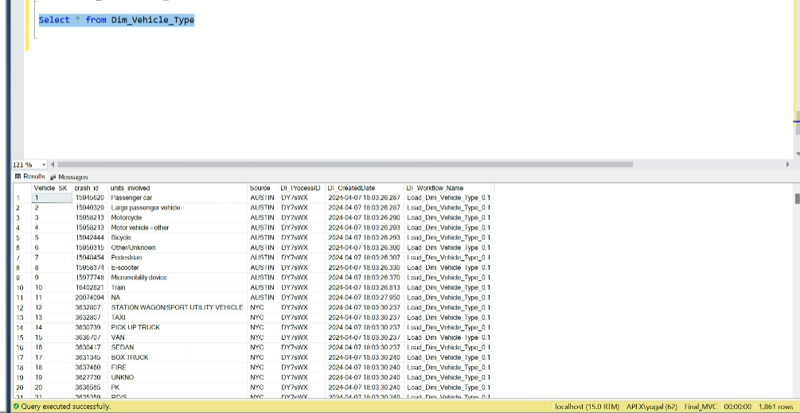

1. **Vehicle Fact (Austin) –**

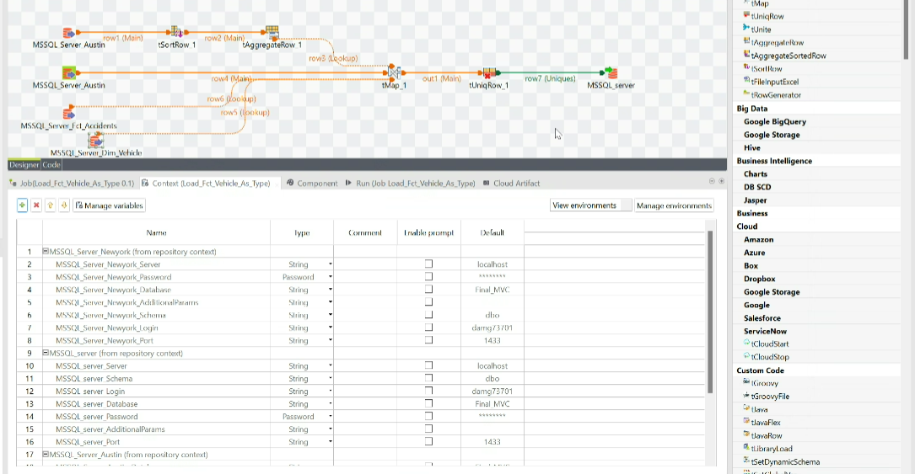

1. **Vehicle Fact (New York) –**

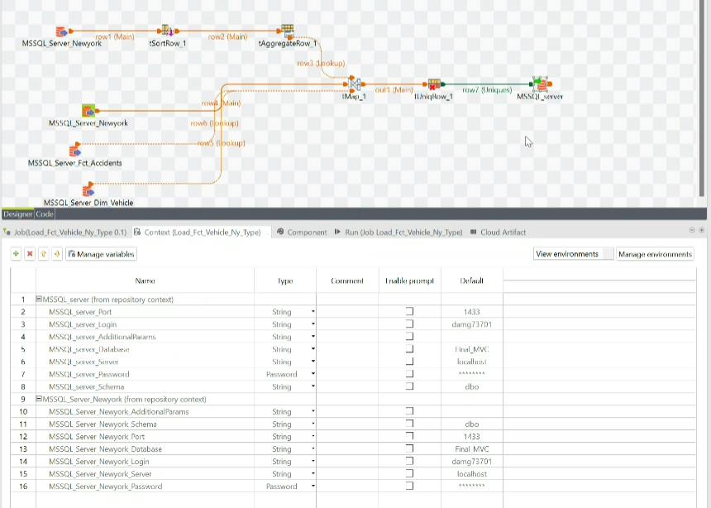

1. **Vehicle Fact (Chicago) –**

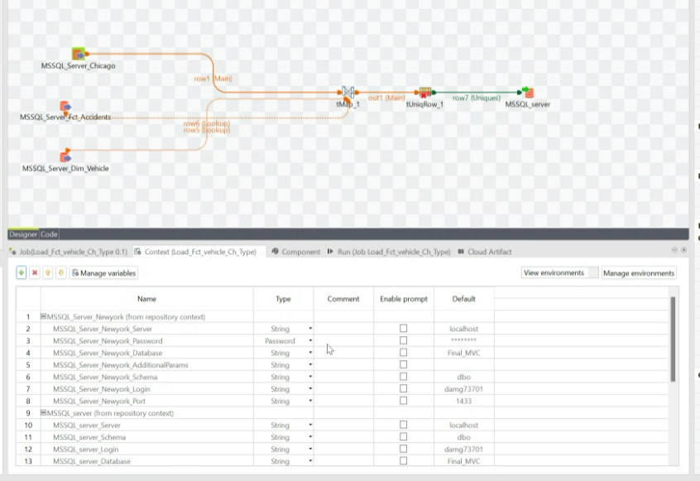

1. **Orchestration Job (Vehicle Fact) –**

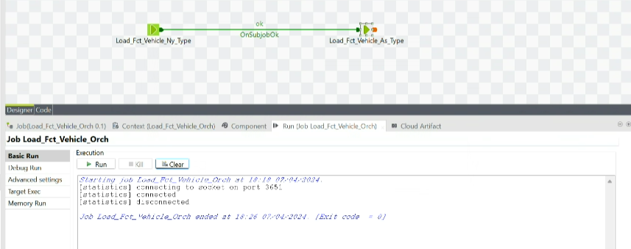

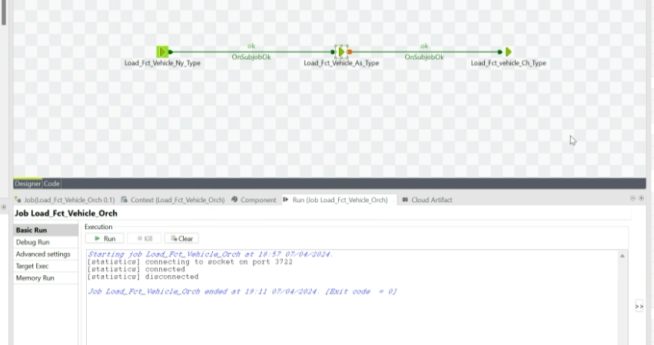

* **Fact Table Loading( Vehicle Fact):-**

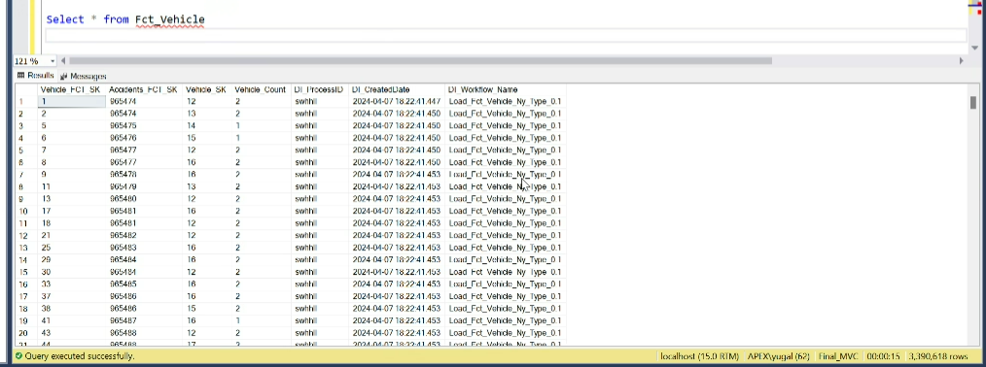

**Count:-**

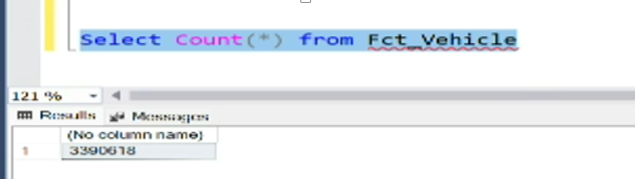

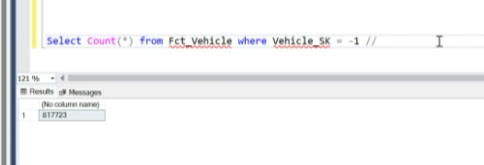

1. **Contribution Dimension (SCD)–**

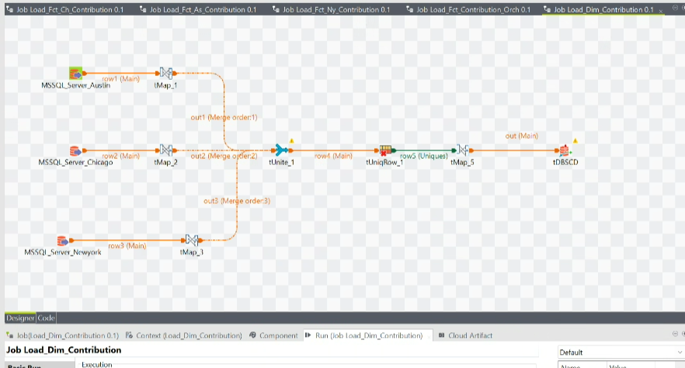

**Count:-**

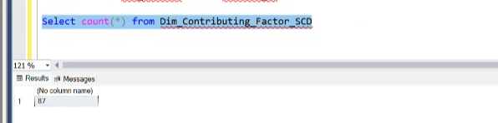

* **Dimension Table Loading( Contribution Dimension):-**

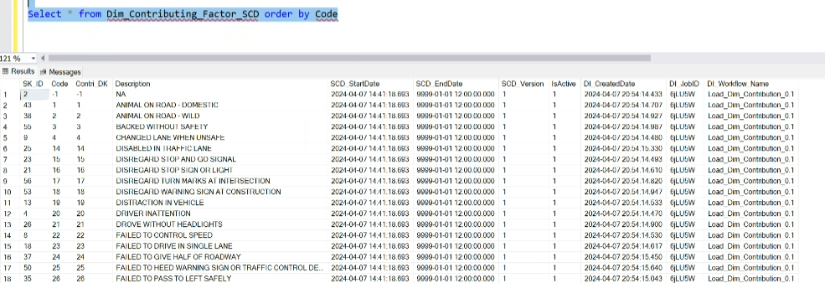

1. **Contribution Fact (Chicago) –**

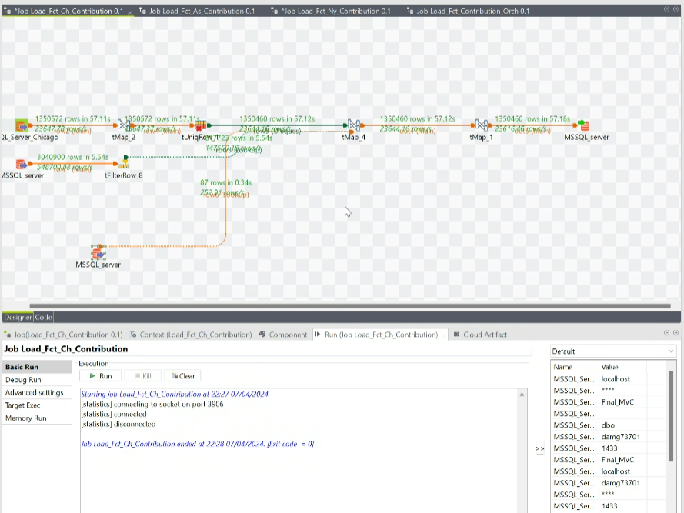

1. **Contribution Fact (Austin) –**

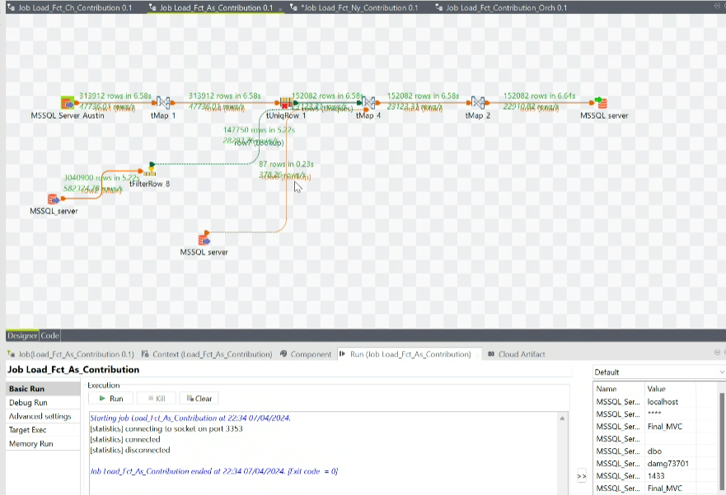

1. **Contribution Fact (New York) –**

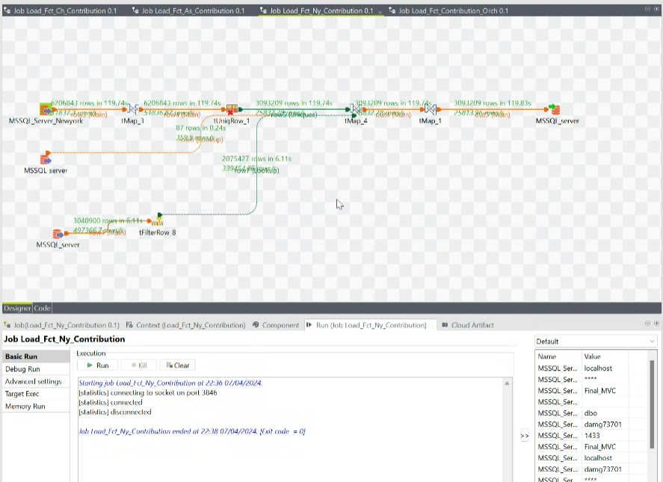

1. **Orchestration Job (Contribution Fact) –**

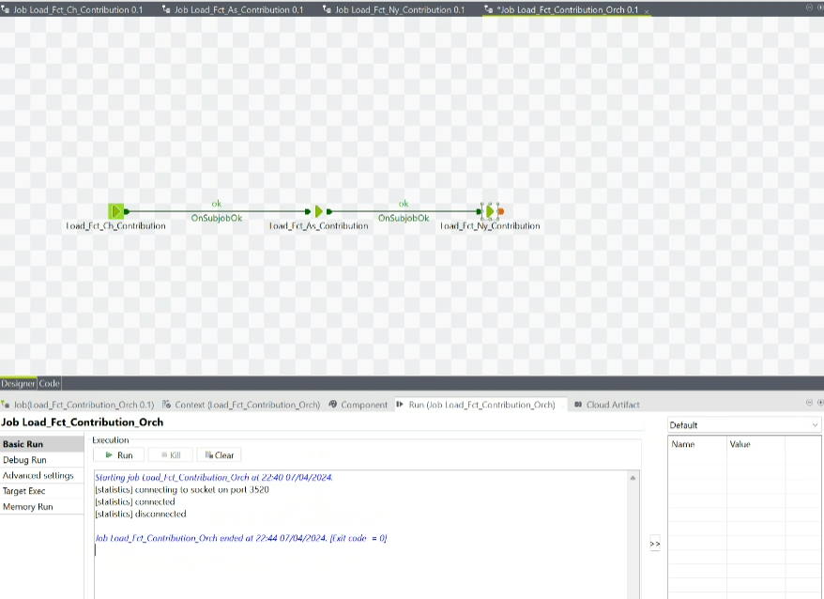

**Dimensional Model Part 2:-**

